Day 12 - 25th june 2025

Data Structures

Data structures in Java.docx in docs to study

A ===> how the character A is stored?
A ====> ASCII = American Standard code for information interchange value 65 ====> binary code
ASCII values are given === by ASNI === American Standard National Institute
Special before 65
A ===> 65 …. 66 = B…..
Small characters … 97 = a. 98 = b

A
65 ===> binary code?

65 / 2 == 1
32 / 2 == 0
16 / 2 == 0
8 / 2 == 0
4 / 2 == 0
2 / 2 == 0
1 / == 1 = ⇒ 1 0 0 0 0 0 1

Bottom to top take the remainders

Task 1:
What is the binary 8 bit representation of A?
2 min
0 1 0 0 0 0 0 1 =

Task 2:
What is the binary value of a?
2min
Hint ascii value is 97..
a
97 ==> binary code?

65 ÷ 2 = 32 == 1
32 ÷ 2 = 16 == 0
16 ÷ 2 = 8 == 0
8 ÷ 2 = 4 == 0
4 ÷ 2 = 2 == 0
2 ÷ 2 = 1 == 0
1 ÷ 2 = 0 == 1

Task 3:

Types of Computer memory with examples.. Explain ..

Cache Memory
Cache is super-fast memory that stores data the CPU uses frequently. It helps speed up the system.
- Example: L1, L2, and L3 cache memory inside Intel Core i7 CPU
RAM (Random Access Memory)
RAM is the temporary memory of a computer. It stores all the active data and programs you're using right now.
- Example: 8GB DDR4 RAM in laptops and desktops

Types of RAM:
DRAM (Dynamic RAM):
Needs refreshing constantly; slower than SRAM.
- Example: Used in system memory modules like 4GB/8GB DDR3/DDR4 RAM.
SRAM (Static RAM):
Faster and doesn’t need refreshing.
- Example: Cache memory in processors like Intel Core i5/i7 chips.

ROM (Read Only Memory)
ROM is permanent memory used to store system startup data and firmware.
- Example: BIOS chip on the motherboard

Types of ROM:
- MROM (Masked ROM):
Pre-programmed during manufacturing.
Example: Firmware inside washing machines or microwave ovens.
- PROM (Programmable ROM):
Users can write data only once.
Example: Chip used in early gaming consoles.
- EPROM (Erasable PROM):
Can be erased with UV light.
Example: Used in early satellite systems for reprogramming.
- EEPROM (Electrically Erasable PROM):
Can be erased and rewritten electrically.
Example: Flash memory in microcontrollers like Arduino or ATM smart cards.
Virtual Memory
When physical RAM is full, part of the hard drive is used as virtual RAM.
Example: Pagefile.sys in Windows or Swap space in Linux systems

Task 4:

What do you understand by data structures..?
Data structures are special ways of organizing and storing data in a computer so that we can use it efficiently. They help us manage large amounts of data by making it easier to search, insert, delete, or update information.
For example: arrays store elements in a fixed order, while linked lists allow flexible memory use. Stacks help with undo features, and queues are perfect for processing tasks one by one. HashMaps give us fast access using keys. Choosing the right data structure can greatly improve the speed and performance of a Java program.
Task 5:

What are the operations on data structures ?

The operations on data structures are the actions we perform to manage and use data efficiently. The main ones include
- Insertion – Adding new elements (e.g., adding a value to an array or a node to a linked list).
- Deletion – Removing elements (like popping from a stack or deleting from a queue).
- Traversal – Visiting every element (e.g., looping through an array or printing a linked list).
- Searching – Finding an element based on value or condition.
- Sorting – Arranging elements in a specific order (like ascending or descending).
- Updating – Modifying an existing element's value.
Each data structure may support these operations differently. For example, insertion is fast in linked lists but slower in arrays due to shifting elements.
Task 6:

What are static and dynamic arrays key points summarize in a table

Feature | Static Array | Dynamic Array
Size | Fixed at compile time | Can grow/shrink at runtime
Memory Allocation | Compile-time | Runtime
Flexibility | Less flexible (no resizing) | More flexible (resizable)
Performance | Faster due to fixed size | Slightly slower due to resizing logic
Example in Java | int[] arr = new int[5]; | ArrayList<Integer> list = new ArrayList<>();
Storage Location | Stores values in contiguous memory | May resize and copy data internally
Use Case | When size is known and fixed | When size is unknown or changes often

Task 7:

Reverse an array. write a code.

11.59 to 12.02

Hint : take a list of nos and display in reverse order..
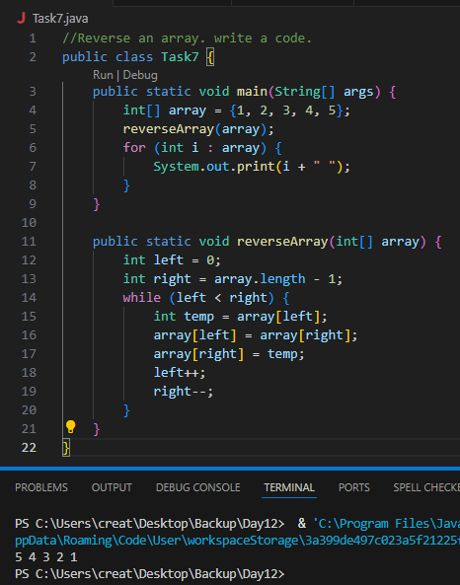

Task 8:

Reverse a string .. write a code.

12.03 to 12.06

Hint: take a name from the user and display the name in reverse order..
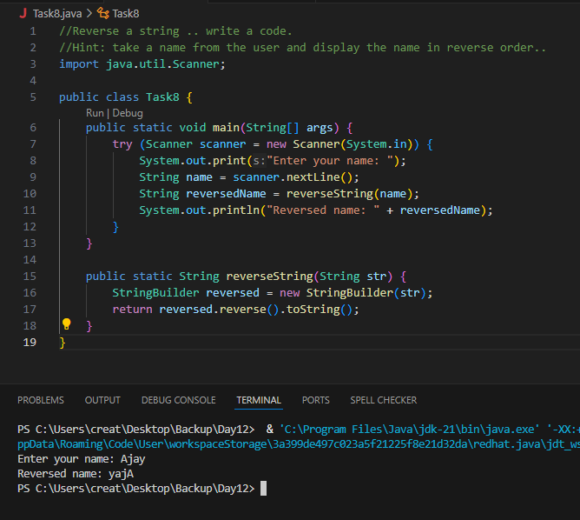

Task 9:

Leetcode and Hackerrank … accounts ..

By Zain – link given for practice

AlgoMaster.io - Master Software Engineering Interviews

10 pax have the above accounts … out of 25 pax..

Task 10:

public class Example {
public static void main (String[] args) {
int[] arr1 = {11, 34, 66, 75};
int n1 = arr1.length;
int[] arr2 = {1, 5, 19, 50, 89, 100};
int n2 = arr2.length;
int[] merge = new int[n1 + n2];
int i = 0, j = 0, k = 0, x;
System.out.print("Array 1: ");
for (x = 0; x < n1; x++)
System.out.print(arr1[x] + " ");
System.out.print("\nArray 2: ");
for (x = 0; x < n2; x++)
System.out.print(arr2[x] + " ");
while (i < n1 && j < n2) {
if (arr1[i] < arr2[j])
merge[k++] = arr1[i++];
else
merge[k++] = arr2[j++];
}
while (i < n1)
merge[k++] = arr1[i++];
while (j < n2)
merge[k++] = arr2[j++];
System.out.print("\nArray after merging: ");
for (x = 0; x < n1 + n2; x++)
System.out.print(merge[x] + " ");
}
}

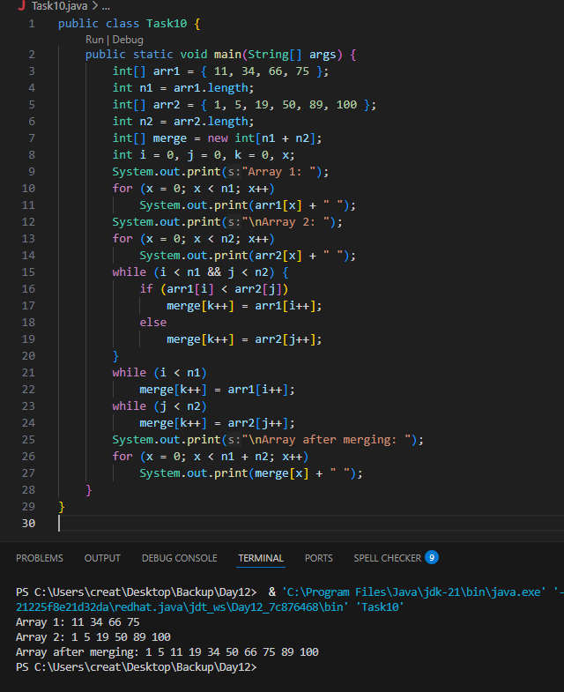

What is the above code snippet doing..?
This program merges two sorted arrays into one sorted array. First, we define arr1 and arr2, which are already sorted. Then we print both arrays so we can see the input values.

We create a third array called merge that has enough space to hold all elements from both arr1 and arr2. Using a loop, we compare each element from both arrays: if an element from arr1 is smaller, it’s added to merge, and we move to the next element in arr1. Otherwise, we take the element from arr2. This way, we build the merged array step-by-step in sorted order.

Once one of the arrays is finished, we copy the remaining elements from the other array into merge. Finally, we print the merged array so we can see the sorted result.

Task 11:

What do you know about hash table?

A Hash Table is a data structure that stores data in the form of key-value pairs, and it allows for very fast data retrieval using a unique key.

Internally, it uses a hash function to convert the key into an index in an array. The value is then stored at that specific index. So instead of searching through the entire dataset, we can directly access the value using the key — which makes operations like search, insert, and delete happen in constant time, on average — O(1).

Task 12:

Wap to create a hash table and display them..

Hint 👍

Import java.util.Hashtable;
Import java.util.Map;

//Map is an interface
//hash table → Slower,sync,thread safe, no null values accepted
// hashmap --> faster while retrieving, asynchro , only one null key and multiple null values..

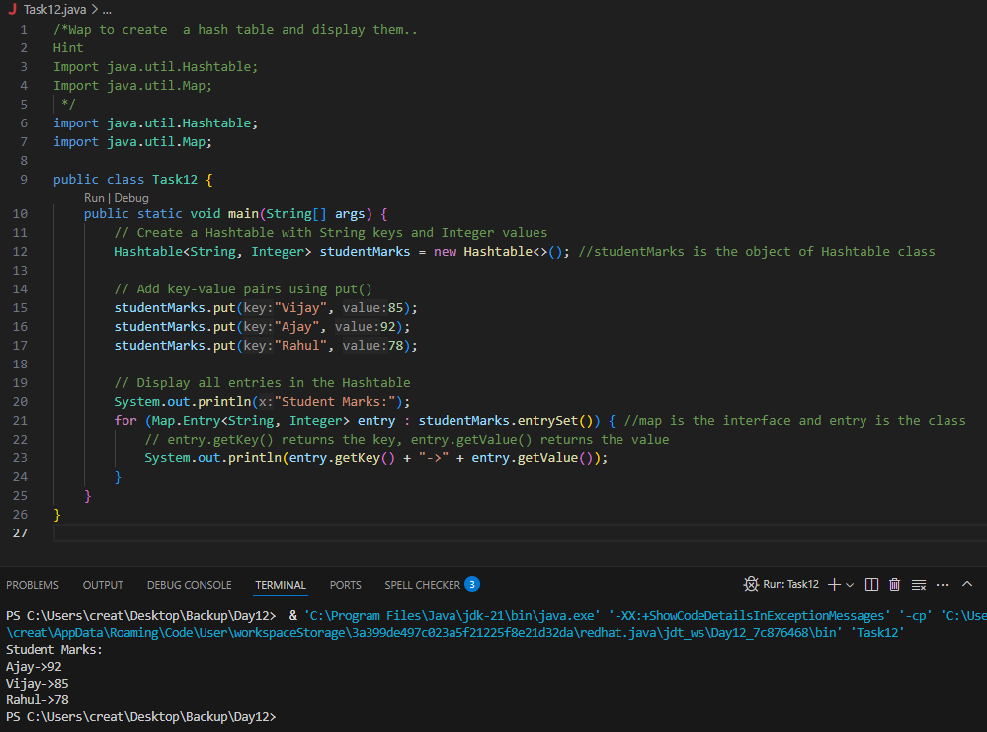

Task 13:
Wap to create a hash map and display them..

import java.io.*;
import java.util.*;

class Task013_DS_HashMap {

public static void main(String args[]) {
HashMap<Integer, String> hmobj1 = new HashMap<>();

HashMap<Integer, String> hmobj2 = new HashMap<Integer, String>();

hmobj1.put(10, "Anitha");
hmobj1.put(20, "Saritha");
hmobj1.put(30, "Ankitha");

hmobj2.put(44, "John");
hmobj2.put(55, "Steve");
hmobj2.put(66, "Jack");

System.out.println("Mapping HashMap hmobj1: " + hmobj1);

System.out.println("Mapping HashMap hmobj2: " + hmobj2);
}
}

//set -- arrayList , replace the values , updates the previous value
//put -- hash table , insert the value, puts a new value
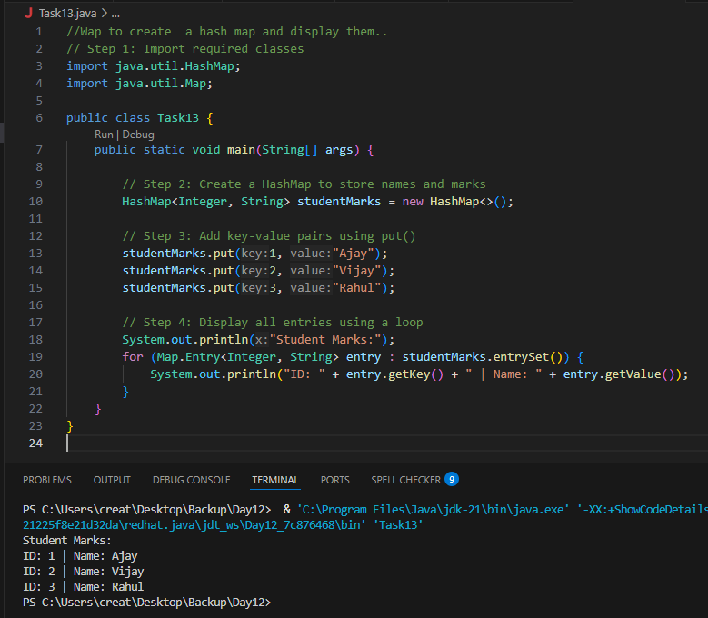
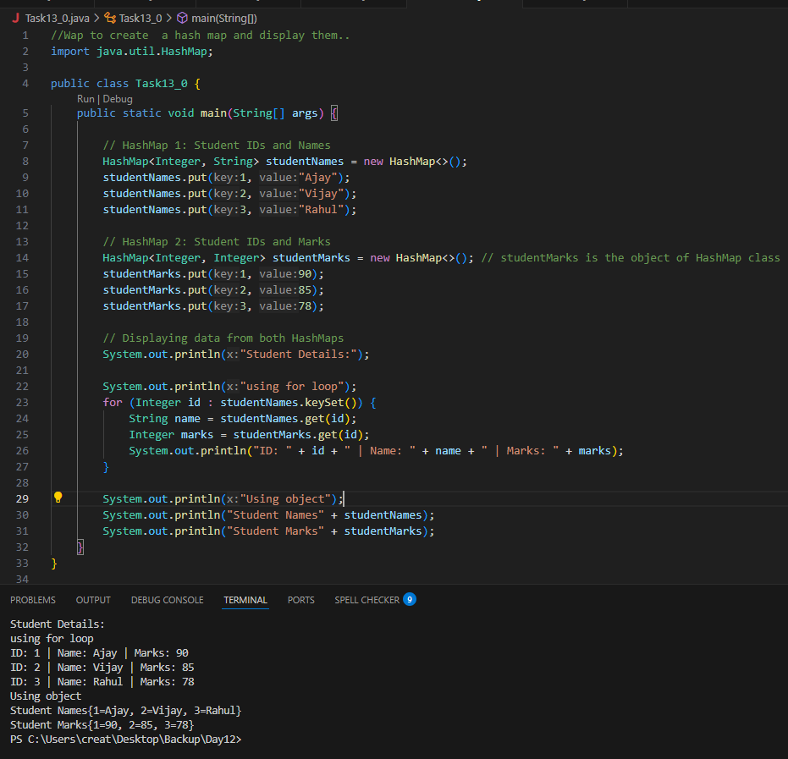

Task 14:

Hash table advantages and disadvantages

Category | Advantages | Disadvantages
Speed | Very fast access time (average case O(1)) for insert, search, and delete | Can slow down if many keys cause collisions
Access Type | Uses keys for direct access to values | No control over element ordering
Scalability | Efficient with large datasets | More memory may be used compared to simpler data structures
Convenience | Easy to implement using HashMap, Hashtable, etc. in Java | HashMap is not thread-safe without synchronization
Flexibility | Can store various types using generics (e.g., <String, Integer>) | Relies on a good hash function — poor ones reduce performance
Usage | Great for applications like caching, user login systems, dictionaries | Not ideal when you need sorting or maintaining insertion order

Linear probing in Hash table
Task 15:
Check the code
public class HashTable<Key, Value> {
private class HashTableNode {
private Key key;
private Value value;
private boolean active;
private boolean tombstoned; // Allow reuse of removed slots
public HashTableNode() {
// All nodes in array will begin initialized this way
key = null;
value = null;
active = false;
tombstoned = false;
}
public HashTableNode(Key initKey, Value initData) {
key = initKey;
value = initData;
active = true;
tombstoned = false;
}
}

private final static int TABLE_SIZE = 9;
private Object[] table;
public HashTable() {
// Since HashNodeTable has generics, we can not have
// a new HashNodeTable[], so use Object[]
table = new Object[TABLE_SIZE];
for (int j = 0; j < TABLE_SIZE; j++)
table[j] = new HashTableNode();
}
public Value put(Key key, Value value) // TBA

Task 16:

Methods of Hash table plz list them..

- put(K key, V value): Inserts a key-value mapping into the Hashtable. If the key already exists, the old value is replaced with the new one.
- get(Object key): Returns the value associated with the specified key. Returns null if the key is not found.
- remove(Object key): Removes the key-value mapping for the specified key from the Hashtable.
- containsKey(Object key): Returns true if the Hashtable contains a mapping for the specified key, otherwise returns false.
- containsValue(Object value): Returns true if the Hashtable maps one or more keys to the specified value, otherwise returns false.
- isEmpty(): Returns true if the Hashtable contains no key-value mappings, otherwise returns false.
- size(): Returns the number of key-value mappings in the Hashtable.
- clear(): Removes all key-value mappings from the Hashtable.
- keySet(): Returns a Set view of the keys contained in the Hashtable.
- values(): Returns a Collection view of the values contained in the Hashtable.
- entrySet(): Returns a Set view of the key-value mappings contained in the Hashtable.
- rehash(): Increases the size of the Hashtable and rehashes all of its keys. This method is protected and typically handled internally by the Hashtable for performance optimization.
- clone(): Returns a shallow copy of the Hashtable instance.

Task 17:

In Task 13 of hash Map .. we were using string and integer / integer and string
Like HashMap<Integer, String>

Can you change to String and string and c if it works
Like this HashMap<String, String> ? will this work?

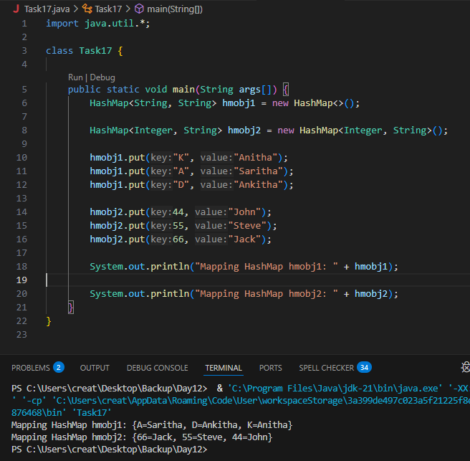

Task 18:

Explain the internal working of a HashMap. With diagram..

A HashMap stores data in key-value pairs and uses a technique called hashing to determine where to store each entry in memory.
Example Code:

Hashing the Key Java calls key.hashCode() to generate a hash code (an integer).
Index Calculation The hash code is converted into an index using:
java
index = (n - 1) & hash
where n is the size of the internal array (called the bucket array).
Storing the Entry
- If the bucket at that index is empty → store the entry.
- If not → collision occurs.
Retrieving a Value (get(key))
- Hash the key again, find the index, and search the bucket (linked list or tree) for the matching key using .equals().

Map<String, String> map = new HashMap<>();
map.put("name", "Ajay");
map.put("city", "Delhi");

Array Index Bucket Content
----------- -------------------------------------
0 null
1 null
2 [key: "city", value: "Delhi"]
3 null
4 [key: "name", value: "Ajay"]
5 null
6 null
7 null

'n' = 110
'a' = 97
'm' = 109
'e' = 101

hashCode = (110 * 31^3) + (97 * 31^2) + (109 * 31) + 101
= (110 * 29791) + (97 * 961) + (109 * 31) + 101
= 3277010 + 93217 + 3379 + 101
= 3364707

index = 3364707 % 8 = 3

//Hash map consists of inbuilt linked lists

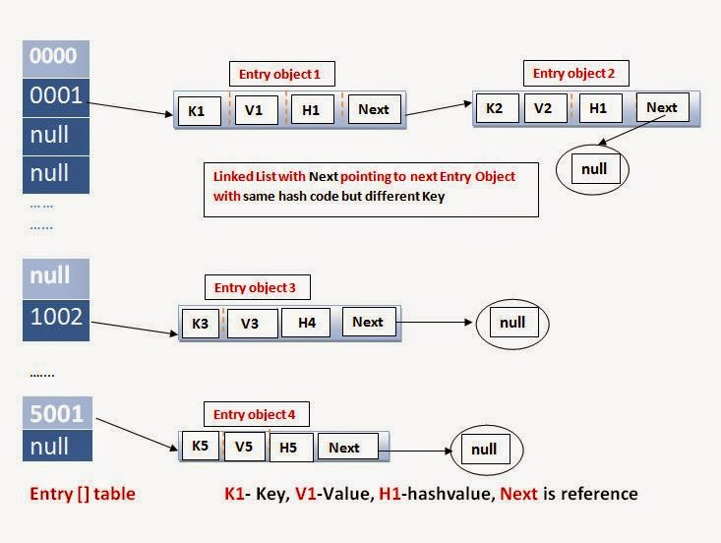

Task 19:

Try to add 1 null value in the key and run the hash map code..

Also add one more null value to the key and see the result..

17.19 to 17.21

Sample 👍

import java.util.*;
import java.io.*;
public class Task019_Ds_HashMapNull {
public static void main(String[] args) {
HashMap hmap=new HashMap();
hmap.put(101,"Prasunamba");
hmap.put(null,"Meher");
hmap.put(null,".MK");
System.out.println(hmap);
}
}
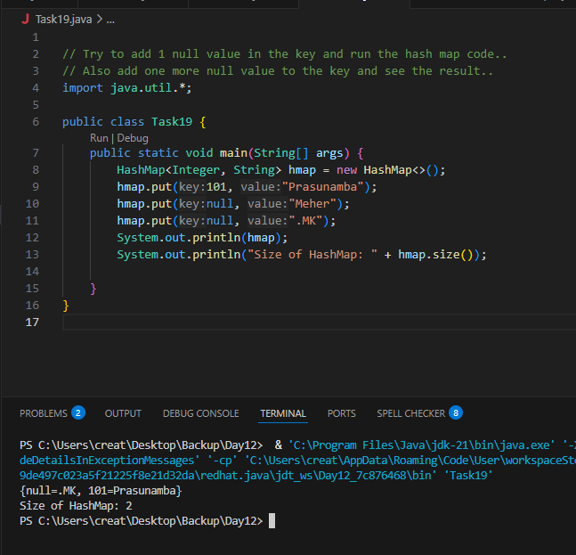

Task 20:

How many methods are there to create a hash Map?

There are several ways to create a HashMap in Java.

1. Using Default Constructor
Map<String, String> map = new HashMap<>();
- Creates an empty HashMap with default capacity (16) and load factor (0.75).

2. Using Initial Capacity

Map<String, String> map = new HashMap<>(50);
- Starts with capacity 50, useful if you know how many entries you’ll store.

3. Using Initial Capacity and Load Factor

Map<String, String> map = new HashMap<>(50, 0.5f);
- Sets custom capacity and load factor.

4. Creating from Another Map

Map<String, String> oldMap = new HashMap<>();
oldMap.put("A", "Apple");
Map<String, String> newMap = new HashMap<>(oldMap);
- Copies all key-value pairs from oldMap into newMap.
5. Using Map.of() (Immutable Map - Java 9+)
Map<String, String> map = Map.of("A", "Apple", "B", "Banana");

- Creates an immutable map (cannot modify).
- Limited to 10 entries with Map.of().
6. Using Map.ofEntries() (Java 9+)

Map<String, String> map = Map.ofEntries(
Map.entry("A", "Apple"),
Map.entry("B", "Banana")
);
- Also immutable, but allows more than 10 entries.
7. Using Collectors.toMap() (Streams)
List<String> list = List.of("A", "B", "C");
Map<String, Integer> map = list.stream()
.collect(Collectors.toMap(str -> str, str -> str.length()));

Task020_DS_HashMapCreateMethods:

Different methods to create a hashmap in java :
1) Constructing a hashmap with default capacity

ex:
HashMap<String, Integer> hm1 = new HashMap<String, Integer>();

2) Constructing a hashmap with a capacity 10

ex:
HashMap<String, Integer> hm2 = new HashMap<String, Integer>(10);

3)copy one map to another map

ex:
HashMap<String, Integer> hm3 = new HashMap<String, Integer>( hm2);

4)
Specifying load factor along with the capacity

ex:
HashMap<String, Integer> hm4= new HashMap<String, Integer>(10, 0.75f);

Initial capacity ===10
Load factor === 0.75f

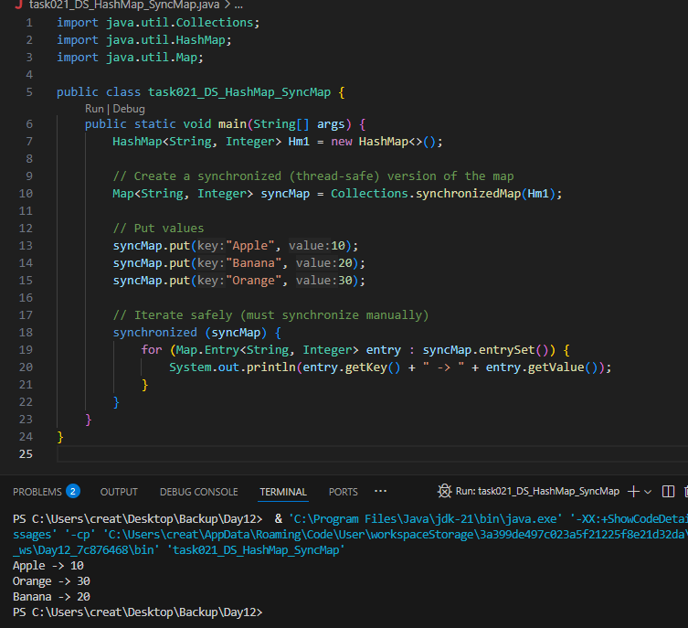

$$$$$$$$$$$$$$$$$$$$$$$$$$$$$$$$$$$$$$$$$$$$$$$$$$$$$$$$$$$$$$$$$$$$$$$$$
Home Tasks:
$$$$$$$$$$$$$$$$$$$$$$$$$$$$$$$$$$$$$$$$$$$$$$$$$$$$$$$$$$$$$$$$$$$$$$$$$

Do hash table have linked list internally?

Yes, Hash Tables (and HashMap in Java) can use linked lists internally — but not always. Let me explain clearly:

Internal Structure of a Hash Table (like Java’s HashMap)
Each entry in a hash table is stored in a bucket (i.e., an array index). When multiple keys hash to the same index, it's called a collision.

To handle this:

Collision Handling: Chaining (Using Linked List)
If two or more keys hash to the same bucket, they are stored in a Linked List at that index.

Each node in the linked list stores:
the key
the value
a reference to the next node
—-----------------------------------------

Do collisions occur in hash Maps? What are they?

What is load factor and how the capacity increases?

Yes, collisions do occur in HashMaps, and understanding them is important for knowing how hash-based structures work internally.

What is a Collision in a HashMap?
A collision happens when two or more keys hash to the same bucket index in the internal array.

Why Do Collisions Occur?
Because:

The number of possible keys is much larger than the number of buckets (array size),

Multiple keys can generate the same hash index using the formula:

Slide 21 ppt – plz work on it..

Map and set

https://leetcode.com/problems/design-hashmap/description/
Leet code :

Add on:

Hash Table - Linear Probing

import java.util.Scanner;
class LinearProbingHashTable {
private int currentSize, maxSize;
private String[] keys;
private String[] vals;

public LinearProbingHashTable(int capacity) {
currentSize = 0;
maxSize = capacity;
keys = new String[maxSize];
vals = new String[maxSize];
}

public void makeEmpty() {
currentSize = 0;
keys = new String[maxSize];
vals = new String[maxSize];
}

public int getSize() {
return currentSize;
}

public boolean isFull() {
return currentSize == maxSize;
}

public boolean isEmpty() {
return getSize() == 0;
}

public boolean contains(String key) {
return get(key) != null;
}

private int hash(String key) {
return key.hashCode() % maxSize;
}

public void insert(String key, String val) {
int tmp = hash(key);
int i = tmp;
do {
if (keys[i] == null) {
keys[i] = key;
vals[i] = val;
currentSize++;
return;
}
if (keys[i].equals(key)) {
vals[i] = val;
return;
}
i = (i + 1) % maxSize;
} while (i != tmp);
}

public String get(String key) {
int i = hash(key);
while (keys[i] != null)
{
if (keys[i].equals(key))
return vals[i];
i = (i + 1) % maxSize;
}
return null;
}

public void remove(String key) {
if (!contains(key))
return;

int i = hash(key);
while (!key.equals(keys[i]))
i = (i + 1) % maxSize;
keys[i] = vals[i] = null;

for (i = (i + 1) % maxSize; keys[i] != null; i = (i + 1) % maxSize) {
String tmp1 = keys[i], tmp2 = vals[i];
keys[i] = vals[i] = null;
currentSize--;
insert(tmp1, tmp2);
}
currentSize--;
}

public void printHashTable() {
System.out.println("\nHash Table: ");
for (int i = 0; i < maxSize; i++)
if (keys[i] != null)
System.out.println(keys[i] +" "+ vals[i]);
System.out.println();
}
}

public class LinearProbingHashTableTest {
public static void main(String[] args) {
Scanner scan = new Scanner(System.in);
System.out.println("Hash Table Test\n\n");
System.out.println("Enter size");

LinearProbingHashTable lpht = new LinearProbingHashTable(scan.nextInt() );

char ch;

do {
System.out.println("\nHash Table Operations\n");
System.out.println("1. insert ");
System.out.println("2. remove");
System.out.println("3. get");
System.out.println("4. clear");
System.out.println("5. size");

int choice = scan.nextInt();
switch (choice) {
case 1 :
System.out.println("Enter key and value");
lpht.insert(scan.next(), scan.next() );
break;
case 2 :
System.out.println("Enter key");
lpht.remove( scan.next() );
break;
case 3 :
System.out.println("Enter key");
System.out.println("Value = "+ lpht.get( scan.next() ));
break;
case 4 :
lpht.makeEmpty();
System.out.println("Hash Table Cleared\n");
break;
case 5 :
System.out.println("Size = "+ lpht.getSize() );
break;
default :
System.out.println("Wrong Entry \n ");
break;
}

lpht.printHashTable();

System.out.println("\nDo you want to continue (Type y or n) \n");
ch = scan.next().charAt(0);
} while (ch == 'Y'|| ch == 'y');
}
}

